PAAREES Perfumes

Boss HUGO Boss Men

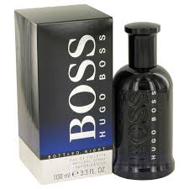

**Boss Only the Brave for Men**

Key Features

* Head notes of Boss Plus Plus Masculine : bergamot, orange, palm leaf, heliotrope
* Base notes of Masculine by Boss : vetiver, musk, sandalwood, patchouli, oakmoss, nutmeg, cloves, cinnamon, anise, tonka bean
* Heart notes of Plus Plus Masculine by Boss : jasmine, birch, sage, cardamom, coriander, lily, violet, green tones
* Boss PLUS PLUS Masculine is a vibrant fragrance full of life.